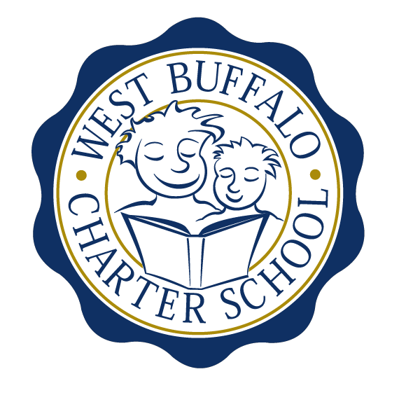

West Buffalo Charter School

Board of Trustees Meeting
January 23, 2017
2:30 PM
D’Youville College, Buffalo, New York

Board Members
Present: Michelle Stevens, James Sampson, Lynn Shea, Joanne Haefner, Lee Pearce, Richard Baer
Excused: Arup Sen, Amy Friedman, James Deuschle
Also Present: Andrea Todoro, Liz Sterns
Quorum Present: Yes

Call to Order
Mrs. Stevens called the meeting to order at 2:32PM. Quorum present.

Proof of Public Notice of Meeting
Media and public announcement was sent on Monday, January 16, 2017 to print, radio, and TV outlets announcing this open meeting. A posting was also sent to Erie County Hall, Buffalo City Hall and Buffalo City Court. In addition, it was publicly displayed at 50 East North Street and posted on the WBCS website. The Board of Trustees was duly notified of this meeting well within the timeline of our bylaws.

Monthly Meeting

Review of the December 19, 2016 Meeting Minutes
Minutes of the December 19th, 2016 Board of Trustees meeting were presented for approval.

Upon motion duly made by Ms. Haefner and seconded by Mrs. Stevens, the minutes of the December 19, 2016 board meeting were approved as presented. All in favor. Non-opposed.

Financial Report
Mrs. Sterns presented the financial reports for the period ending December 31st, 2016 (a copy is attached hereto and made a part hereof).

- Discussion regarding overall expansion plan (i.e.), timing of physical move.
- Discussion regarding Phase V.

Upon motion duly made by Mr. Sampson and seconded by Ms. Haefner, the December, 2016 financial statements were approved as presented. All in favor. Non-opposed.

School Leader Report

- Discussion regarding the Opioid Prevention Program. The School Nurse as well as Mrs. Sterns and Mrs. Todoro will be trained in the use of this product. The Department of Health will provide free kits for each trained person.

Upon motion duly made by Ms. Haefner and seconded by Mrs. Stevens, the Opioid Overdose Prevention Program policy was approved as presented. All in favor. Non-opposed.

- February BoT date change requested by Mrs. Todoro and Mrs. Sterns as they will both be traveling to New York City for a Special Education Collaborative on February 26th for the conference on the 27th. The proposed rescheduled date for the board meeting will be on Tuesday, February 28th.
- Discussion regarding teachers who are currently on a teacher improvement plan.
- Mrs. Todoro presented the winter internal assessment data.
- Discussion regarding marketing/fundraising.

Adjournment
Being that there is no further business to discuss, a motion to dismiss was made by Mr. Sampson and seconded by Mrs. Pearce. The meeting was adjourned 4:08 PM.

Respectfully submitted,
Leslie Bunis Ohl

Please note the following date change for the February meeting:

The next WBCS board meeting will take place on Tuesday, February 28th, 2:30 PM at D’Youville College, Bauer Family Academic Center, Room 105.

